|  |  |
| --- | --- |
| **Good Friday 2015** | msotw9_temp0 |

## **St Andrew’s Church, Orford with Longford**

### The Liturgy of the Day

The Liturgy of the Word

*The procession enters in* ***silence.*** All kneel for silent prayer.

**The Collect of the Day:**

Almighty Father,

look with mercy on this your family

for which our Lord Jesus Christ

was content to be betrayed

and given up into the hands of sinners

and to suffer death upon the cross;

who is alive and glorified

with you and the Holy Spirit,

one God, now and for ever. **Amen**

*Sit* for **A reading from the book of the prophet Isaiah** *(Isa. 52. 13- 53. 12)*

See, my servant shall prosper; he shall be exalted and lifted up, and shall be very high. Just as there were many who were astonished at him – so marred was his appearance, beyond human semblance, and his form beyond that of mortals – so he shall startle many nations; kings shall shut their mouths because of him; for that which had not been told them they shall see, and that which they had not heard they shall contemplate.

Who has believed what we have heard? And to whom has the arm of the Lord been revealed? For he grew up before him like a young plant, and like a root out of dry ground; he had no form or majesty that we should look at him, nothing in his appearance that we should desire him. He was despised and rejected by others; a man of suffering and acquainted with infirmity; and as one from whom others hide their faces he was despised, and we held him of no account. Surely he has borne our infirmities and carried our diseases; yet we accounted him stricken, struck down by God, and afflicted. But he was wounded for our transgressions, crushed for our iniquities; upon him was the punishment that made us whole, and by his bruises we are healed.

All we like sheep have gone astray; we have all turned to our own way, and the Lord has laid on him the iniquity of us all. He was oppressed, and he was afflicted, yet he did not open his mouth; like a lamb that is led to the slaughter, and like a sheep that before its shearers is silent, so he did not open his mouth. By a perversion of justice he was taken away. Who could have imagined his future?

For he was cut off from the land of the living, stricken for the transgression of my people. They made his grave with the wicked and his tomb with the rich, although he had done no violence, and there was no deceit in his mouth. Yet it was the will of the Lord to crush him with pain. When you make his life an offering for sin, he shall see his offspring, and shall prolong his days; through him the will of the Lord shall prosper. Out of his anguish he shall see light; he shall find satisfaction through his knowledge. The righteous one, my servant, shall make many righteous, and he shall bear their iniquities. Therefore I will allot him a portion with the great, and he shall divide the spoil with the strong; because he poured out himself to death, and was numbered with the transgressors; yet he bore the sin of many, and made intercession for the transgressors.

Reader This is the word of the Lord

**All: Thanks be to God**

**Hymn:** 127 "When I survey the wondrous cross" (*remain seated)*

**A reading from the letter to the Hebrews** *(Heb. 10. 16-25)*

“This is the covenant I will make with them after that time, says the Lord. I will put my laws in their hearts, and I will write them on their minds.” Then he adds: “Their sins and lawless acts I will remember no more.” And where these have been forgiven, sacrifice for sin is no longer necessary.

Therefore, brothers and sisters, since we have confidence to enter the Most Holy Place by the blood of Jesus, by a new and living way opened for us through the curtain, that is, his body, and since we have a great priest over the house of God, let us draw near to God with a sincere heart and with the full assurance that faith brings, having our hearts sprinkled to cleanse us from a guilty conscience and having our bodies washed with pure water. Let us hold unswervingly to the hope we profess, for he who promised is faithful. And let us consider how we may spur one another on toward love and good deeds, not giving up meeting together, as some are in the habit of doing, but encouraging one another—and all the more as you see the Day approaching.

Reader This is the word of the Lord

**All: Thanks be to God**

Hymn: 123 "There is a green hill"

**The reading of the Passion of our Lord Jesus Christ according to John:**

*Please remain seated until the pause, which follows* "Then he handed him over to be crucified" ***Stand.***

*The reading concludes with a short period of silence.*

**The Sermon** (*please sit)*

The Proclamation of the Cross

*Please kneel. During this hymn, the Cross is brought into church, and placed in front of the altar.*

Hymn: 120 "O sacred head, surrounded”

Priest: We adore you, O Christ, and we bless you

**All: because by your holy cross**

**you have redeemed the world**

Priest: This is the wood of the cross

on which hung the Saviour of the world

**All: Come, let us worship.**

Priest: O Saviour of the world

who by your cross and precious blood have redeemed us,

**All: save us and help us, we humbly pray.**

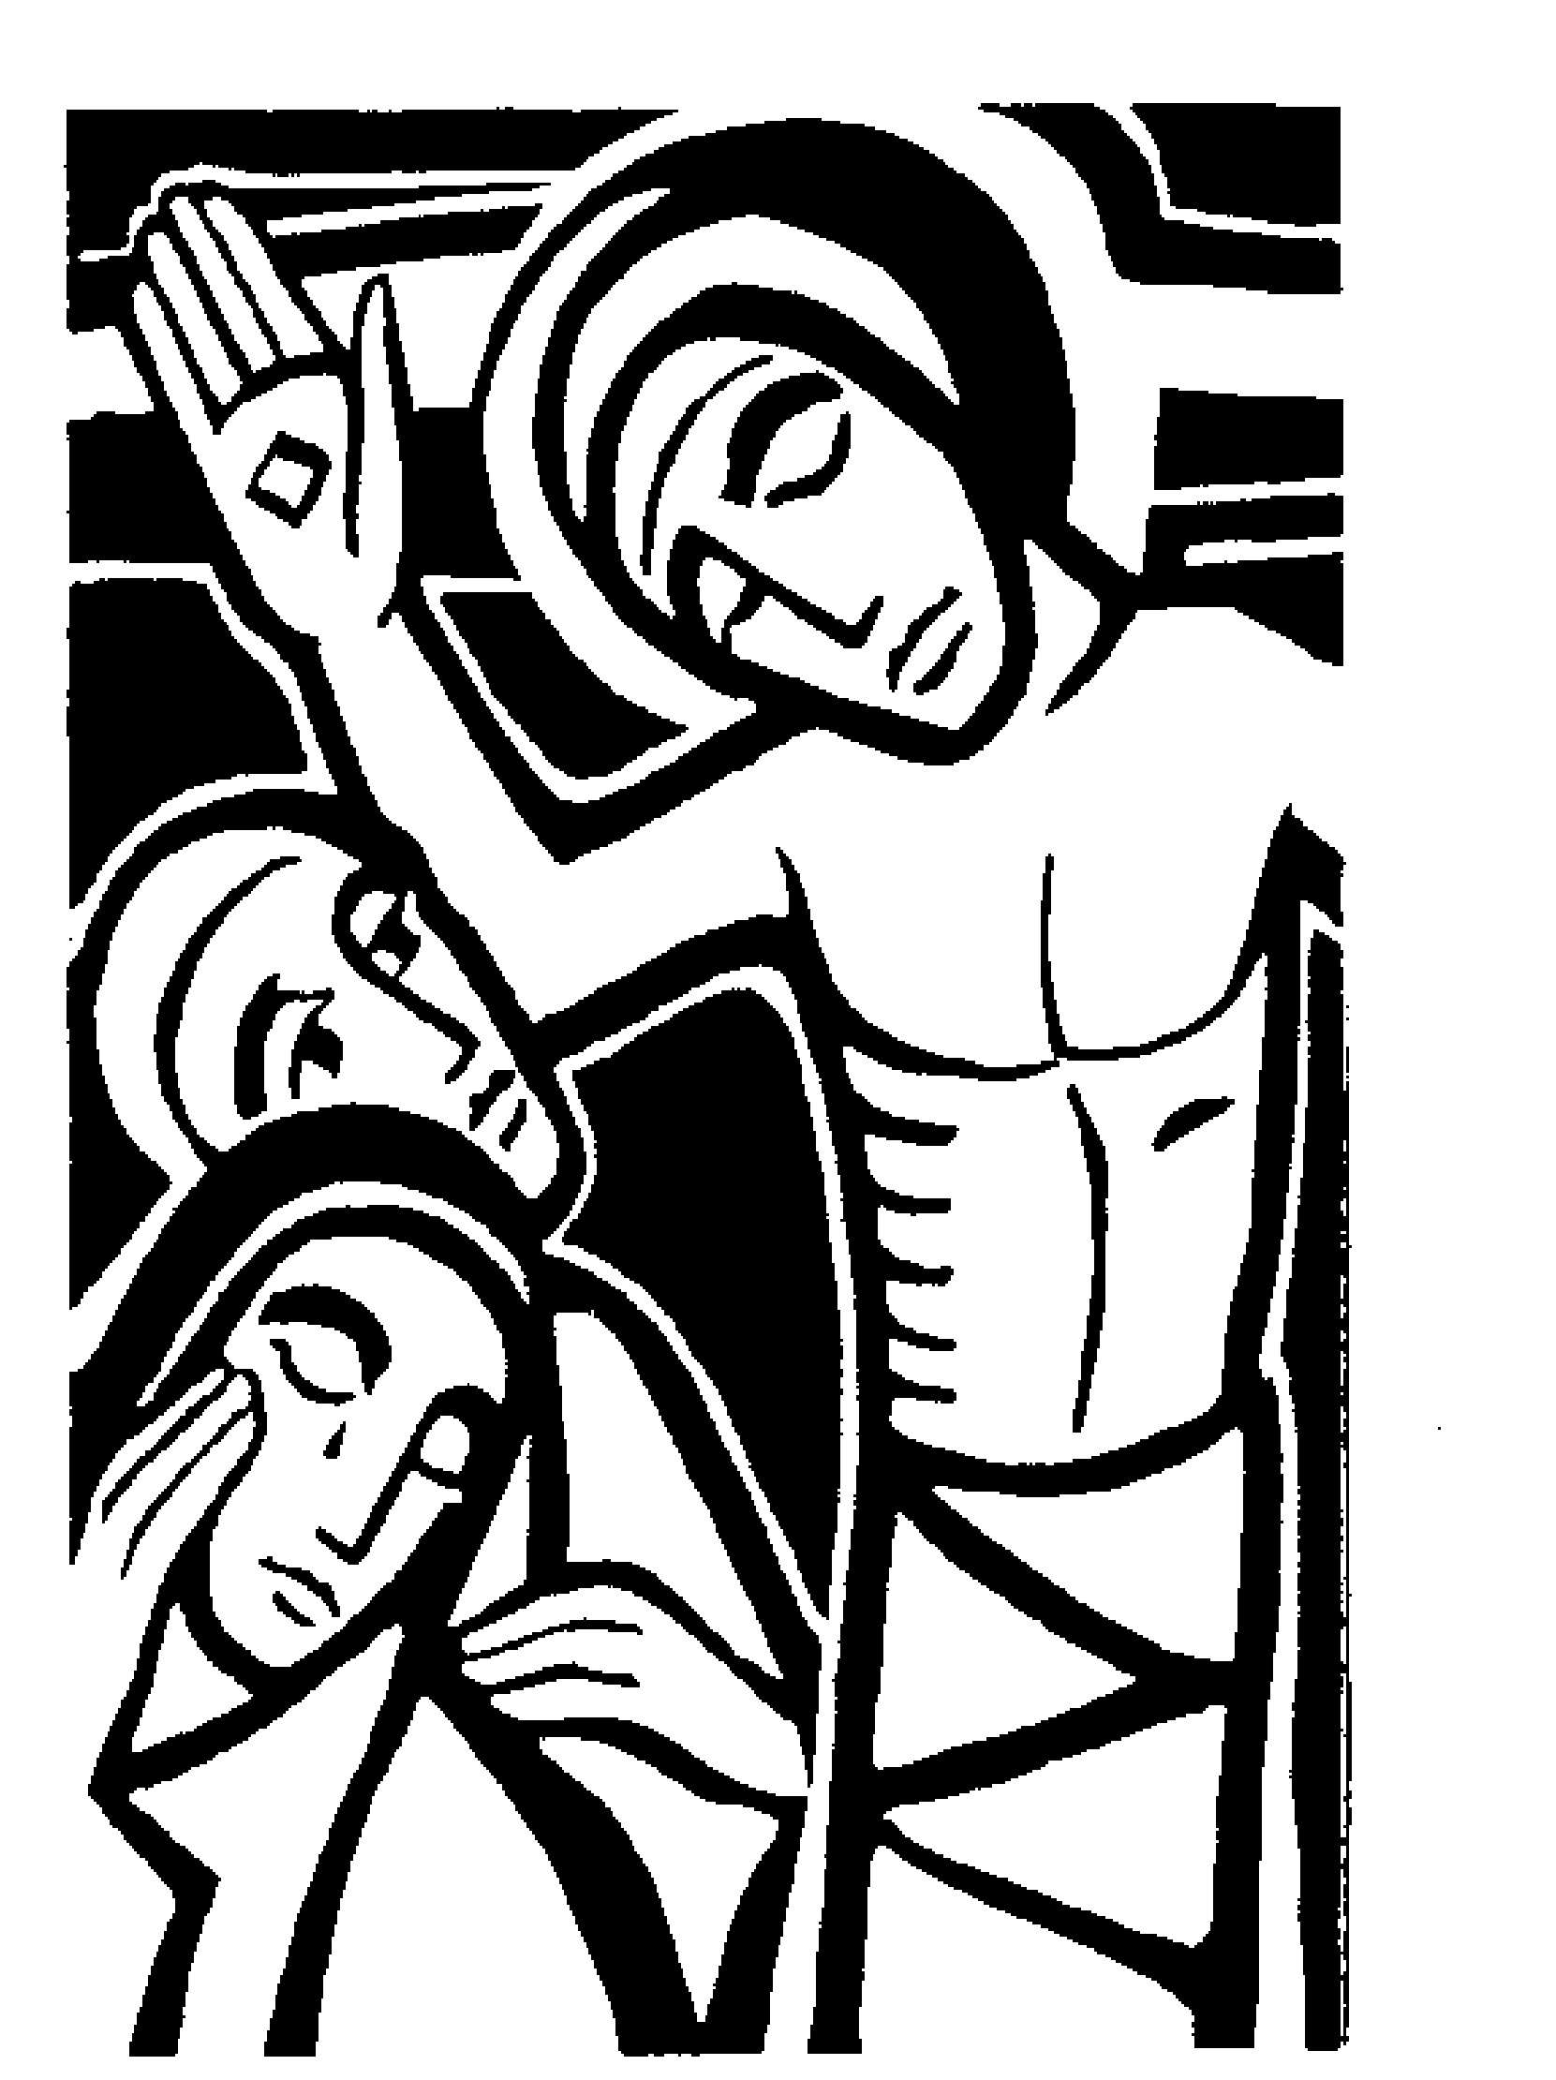

*You are now invited to come forward and venerate the Cross. Simply come and stand/kneel in front of the Cross, and read the Prayer of Veneration. Then stand, and bow before the Cross before returning to your place.*



*When all have venerated the Cross, we sing:*

Jesus, remember me when you come into your Kingdom.

Jesus, remember me when you come into your Kingdom.

Jesus, remember me when you come into your Kingdom.

Jesus, remember me when you come into your Kingdom.

Jesus, remember me when you come into your Kingdom.

Jesus, remember me when you come into your Kingdom.

Priest: Father, hear our prayer and forgive us.

#### All: Unstop our ears

**that we may receive the gospel of the Cross.**

**Lighten our eyes**

**that we may see your glory**

**in the face of your Son.**

**Penetrate our minds**

**that your truth may make us whole.**

**Irradiate our hearts with your love**

**that we may love one another for Christ's sake.**

**Father, forgive us.**

*After a period of silence:*

Priest: We glory in your cross, O Lord,

and praise you for your mighty resurrection;

**All: For by virtue of your cross**

**joy has come into our world.**

Priest: God be gracious to us and bless us

and make his face shine upon us.

**All: Let your ways be made known on earth;**

**your liberating power among all nations.**

Priest: Let the peoples praise you, O God;

let all the peoples praise you.

**All: We glory in your cross, O Lord,**

**and praise you for your mighty resurrection;**

**for by virtue of your cross**

**joy has come into the world.**

*Remain kneeling to sing:*

**Hymn:**  121 "Sing, my tongue, the glorious battle”

The Intercession

The response to “Lord hear us" is

**All: "Lord, graciously hear us"**

The Ministry of the Sacrament

*The altar is prepared in silence*

Priest: Standing at the foot of the cross

let us pray with confidence as our Saviour taught us:

All: Our Father, who art in heaven,

hallowed be thy name;

thy kingdom come; thy will be done;

on earth, as it is in heaven.

Give us this day our daily bread.

And forgive us our trespasses,

as we forgive those who trespass against us.

And lead us not into temptation; but deliver us from evil.

For thine is the kingdom, the power and the glory,

for ever and ever. Amen.

All (sing): Lamb of God, you take away the sin of the world,

have mercy on us.

Lamb of God, you take away the sin of the world, have mercy on us.

Lamb of God, you take away the sin of the world,

grant us peace.

Priest: Jesus is the Lamb of God

who takes away the sin of the world.

Happy are those who are called to his supper.

**All: Lord, I am not worthy**

**but only say the word, and I shall be healed.**

*Everyone is invited to receive the sacrament.*

**Hymn during Communion:**

Were you there when they crucified my Lord?

Were you there when they crucified my Lord?

Oh! Sometimes it causes me to tremble, tremble, tremble,

Were you there when they crucified my Lord?

Were you there when they nailed him to the tree?

Were you there when they nailed him to the tree?

Oh! Sometimes it causes me to tremble, tremble, tremble,

Were you there when they nailed him to the tree?

Were you there when they laid him in the tomb?

Were you there when they laid him in the tomb?

Oh! Sometimes it causes me to tremble, tremble, tremble,

Were you there when they laid him in the tomb?

*The service concludes with the following collect:*

Most merciful God,

who by the death and resurrection of your Son Jesus Christ

delivered and saved mankind:

grant that by faith in him who suffered on the cross,

we may triumph in the power of his victory;

through Jesus Christ our Lord. **Amen**

**Hymn** 172 "The head that once was crowned with thorns"

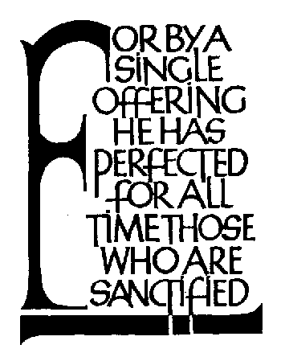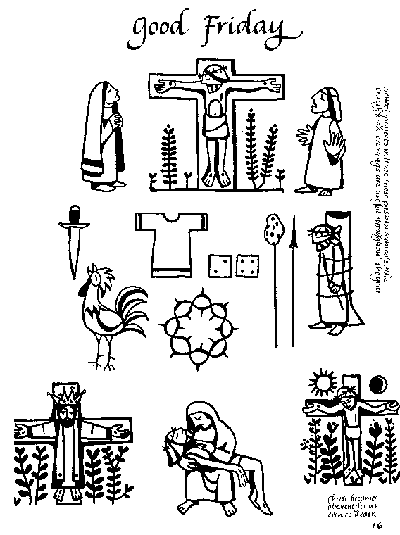

**Readings for Good Friday 2015:**

**A reading from the book of the prophet Isaiah**

See, my servant shall prosper; he shall be exalted and lifted up, and shall be very high. Just as there were many who were astonished at him – so marred was his appearance, beyond human semblance, and his form beyond that of mortals – so he shall startle many nations; kings shall shut their mouths because of him; for that which had not been told them they shall see, and that which they had not heard they shall contemplate.

Who has believed what we have heard? And to whom has the arm of the Lord been revealed? For he grew up before him like a young plant, and like a root out of dry ground; he had no form or majesty that we should look at him, nothing in his appearance that we should desire him. He was despised and rejected by others; a man of suffering and acquainted with infirmity; and as one from whom others hide their faces he was despised, and we held him of no account. Surely he has borne our infirmities and carried our diseases; yet we accounted him stricken, struck down by God, and afflicted. But he was wounded for our transgressions, crushed for our iniquities; upon him was the punishment that made us whole, and by his bruises we are healed.

All we like sheep have gone astray; we have all turned to our own way, and the Lord has laid on him the iniquity of us all. He was oppressed, and he was afflicted, yet he did not open his mouth; like a lamb that is led to the slaughter, and like a sheep that before its shearers is silent, so he did not open his mouth. By a perversion of justice he was taken away. Who could have imagined his future?

For he was cut off from the land of the living, stricken for the transgression of my people. They made his grave with the wicked and his tomb with the rich, although he had done no violence, and there was no deceit in his mouth. Yet it was the will of the Lord to crush him with pain. When you make his life an offering for sin, he shall see his offspring, and shall prolong his days; through him the will of the Lord shall prosper. Out of his anguish he shall see light; he shall find satisfaction through his knowledge. The righteous one, my servant, shall make many righteous, and he shall bear their iniquities. Therefore I will allot him a portion with the great, and he shall divide the spoil with the strong; because he poured out himself to death, and was numbered with the transgressors; yet he bore the sin of many, and made intercession for the transgressors.

###### This is the word of the Lord

##### All: Thanks be to God

**Hymn:** 127 "When I survey" (*remain seated)*

**A reading from the letter to the Hebrews**

“This is the covenant I will make with them after that time, says the Lord. I will put my laws in their hearts, and I will write them on their minds.” Then he adds: “Their sins and lawless acts I will remember no more.” And where these have been forgiven, sacrifice for sin is no longer necessary.

Therefore, brothers and sisters, since we have confidence to enter the Most Holy Place by the blood of Jesus, by a new and living way opened for us through the curtain, that is, his body, and since we have a great priest over the house of God, let us draw near to God with a sincere heart and with the full assurance that faith brings, having our hearts sprinkled to cleanse us from a guilty conscience and having our bodies washed with pure water. Let us hold unswervingly to the hope we profess, for he who promised is faithful. And let us consider how we may spur one another on toward love and good deeds, not giving up meeting together, as some are in the habit of doing, but encouraging one another—and all the more as you see the Day approaching.

This is the word of the Lord

**All: Thanks be to God**

**INTERCESSIONS FOR GOOD FRIDAY:**

President: God sent his Son into the world, not to condemn it the world, but that the world might be saved through him. Therefore we pray to our heavenly Father for people everywhere according to their needs.

# Intercessor: Let us pray for the Church of God throughout the world –

for unity in faith, in witness and in service

for bishops and other ministers, and those whom they serve

for our bishop, Paul, and the people of this diocese

for all Christians in this place

for those to be baptised

for those who are mocked and persecuted for their faith

that God will confirm his Church in faith,

increase it in love, and preserve it in peace.

*(pause)*

Lord, hear us

**All: Lord, graciously hear us.**

Prayer: *Almighty and everlasting God,*

*by whose Spirit the whole body of the Church is governed and sanctified:*

*hear our prayer which we offer for all your faithful people;*

*that in their vocation and ministry*

*may serve you in holiness and truth to the glory of your Name;*

*through our Lord and Saviour Jesus Christ.* **Amen**

Intercessor: Let us pray for the nations of the world and their leaders –

for Elizabeth our Queen and the Parliament of this land

for those who administer the law and all who serve in public office

for all who strive for justice and reconciliation

that by God’s help the world may live in peace and freedom.

*(pause)*

Lord, hear us

**All: Lord, graciously hear us.**

Prayer: *Most gracious God and Father, in whose will is our peace:*

*turn our hearts and the hearts of all to yourself,*

*that by the power of your Spirit*

*the peace which is founded on justice*

*may be established throughout the world;*

*through Jesus Christ our Lord.* **Amen**

Intercessor: Let us pray for God’s ancient people, the Jews, the first to hear his word –

for greater understanding between Christian and Jew

for the removal of our blindness and bitterness of heart

that God will grant us grace to be faithful to his covenant

and to grow in the love of his name.

*(pause)*

Lord, hear us

**All: Lord, graciously hear us.**

Prayer: *Lord God of Abraham*

*bless the children of your covenant, both Jew and Christian;*

*take from us all blindness and bitterness of heart,*

*and hasten the coming of your kingdom,*

*when the Gentiles shall be gathered in,*

*all Israel shall be saved,*

*and we shall dwell together in mutual love and peace*

*under the one God and Father of our Lord Jesus Christ*. **Amen**

Intercessor: Let us pray for those who do not believe the Gospel of Christ –

for those who have not heard the message of salvation

for all who have lost faith

for the contemptuous and scornful

for those who are enemies of Christ and persecute those who follow him

for all who deny the faith of Christ crucified

that God will open their hearts to the truth

and lead them to faith and obedience.

*(pause)*

Lord, hear us

**All: Lord, graciously hear us.**

Prayer: *Most merciful God, creator of all the people of the earth,*

*have compassion on all who do not know you,*

*and by the preaching of your Gospel with grace and power,*

*gather them into the one fold of the one Shepherd, Christ our Lord.* **Amen**

Intercessor: Let us pray for all those who suffer –

for those who are deprived and oppressed

for those who are sick

for those in darkness, in doubt and in despair,

in loneliness and in fear

for the victims of false accusations and violence

for all at the point of death and those who watch beside them

that God in his mercy will sustain them with the knowledge of his love.

*(pause)*

Lord, hear us

**All: Lord, graciously hear us.**

Prayer: *Almighty and everlasting God*

*the comfort of the sad, the strength of those who suffer;*

*hear the prayers of your children who cry out of any trouble:*

*and to every distressed soul grant mercy, relief and refreshment,*

*through Jesus Christ our Lord.* **Amen**

Intercessor: Let us commend ourselves and all God’s children to his unfailing love,

and pray for the grace of a holy life,

that, with all who have died in the peace of Christ,

may come to the fullness of eternal life

and the joy of the resurrection.

*(pause)*

Lord, hear us

**All: Lord, graciously hear us.**

Prayer: O God of unchangeable power and eternal light

look favourably on your whole Church,

that wonderful and sacred mystery,

and by the tranquil operation of your perpetual providence

carry out the work of our salvation:

and let the whole world feel and see

that things which were cast down are being raised up

and things which had grown old are being made new

and that all things are returning to perfection

through him from whom they took their origin,

even Jesus Christ our Lord,

who is alive and reigns with you,

in the unity of the Holy Spirit,

one God, now and for ever. **Amen.**

updated in line with Times and Seasons p.316ff